**Let’s keep Duns litter free!**

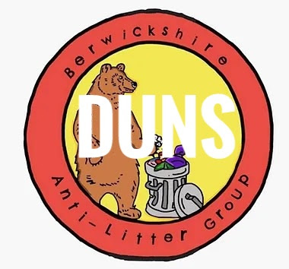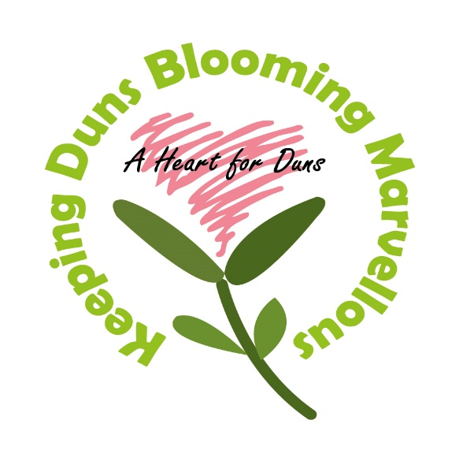

**Whether you keep your own street litter free or join us to tackle different areas, you can make a difference.**

**Please meet outside the Volunteer Hall.**

**Apr - Wednesday 10th 10am**

**May - Thursday 2nd 2pm**

**May - Friday 24th 10am**

**June - Saturday 15th 2pm**

**July - Sunday 7th 10am**

**July - Monday 29th 2pm**

**Aug - Tuesday 20th 10am**

**Sept - Wednesday 11th 2pm**

**Oct - Thursday 3rd 10am**

**Oct - Friday 25th 2pm**

**Nov - Saturday 16th 10am**

**Dec - Sunday 8th 2pm**

**Litter pickers can be supplied.**