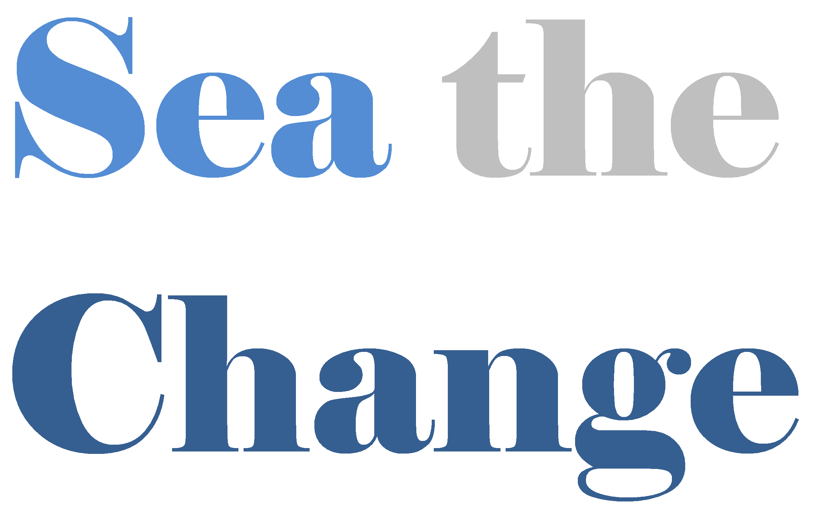
Volunteer Application Form

Thank you very much for your interest in volunteering for Sea the Change.

Any information given on this form is confidential and covered by the Data Protection Act 1998

Please tell us about yourself

Title |  | Forename(s)
Surname

Address

Telephone
Email
Emergency contact:
(Name, relationship to you & contact number)
Please select which method(s) you would prefer for contacting you about your volunteer application | Phone  Email  Letter

Please tell us why you would like to volunteer for Sea the Change (you can tick more than one box)

I want to help reduce single use plastics |  | Other:
I want to develop new skills
Give something back in my community
To make myself more employable
Sharing my skills and experience
I’m interested in meeting new people
To gain my Duke of Edinburgh Award
I believe in this cause
I’d rather volunteer than donate money

Which days/ times are you available to volunteer?.

 | Mon | Tue | Wed | Thu | Fri | Sat | Sun
Morning
Afternoon
Evening

Various:

Which aspects of Sea The Change are you interested in volunteering with?.

Beach wheelchair bookings |  | Other:
Beach wheelchair maintenance
Beach cleans
Community cleans
Admin
Fundraising
Marketing & Events

Any further information you’d like to tell us:

Volunteering status

The right to volunteer in the UK can be dependent on your citizenship and UK immigration status so please make sure that you are allowed to volunteer on your visa (depending on volunteering role).

References

You may be asked to provide us with the details of two people whom we may contact as referees (depending on the volunteering role), to comment on your suitability for volunteering. These can be friends or colleagues but not family members, and must have known you for six months or more.

Keeping you informed about Sea the Change

Your support means a lot to Sea the Change. Together we can do amazing things to reduce our impact on the world. We want you to see the difference your support makes, and we’d love to stay in contact by e-mail to let you know about the work of Sea the Change and how you can help through fundraising, campaigning and volunteering.
So please tick the boxes below to let us know you are happy to hear from us in this way:
[ ] Yes, please keep me updated by e-mail

